| C:\Users\User\AppData\Local\Microsoft\Windows\INetCache\Content.Word\Mathematical Sciences vertical small Logo-01.png |
| --- |
| MASTER OF SCIENCE GRADUATION REPORT |
| JUNE 2025 |
|  |
|  |
|  |

SUBMITTED

To The

ACADEMIC COUNCIL

STRATHMORE UNIVERSITY

By

The Dean

STRATHMORE INSTITUTE OF MATHEMATICAL SCIENCES

**TABLE OF CONTENTS**

# 

**TABLE OF CONTENTS 2**

**1.0 EXECUTIVE SUMMARY 1**

**1.1 TREND ANALYSIS 1**

1.1.1 Number of Graduands 1

1.1.2 Summary of 2023 Intake by Program and Gender 2

**1.1.3 Masters of Science Graduation Rates** 3

2023 Cohort graduands Summary 3

**2.0 CLASS OF 2025 STATISTICS 5**

2.1 Overall Number of MSc. 2025 Graduands 5

**3.0 CLASS OF 2025 MASTERS GRADUATION LIST 6**

3.1 MASTER OF SCIENCE IN DATA SCIENCE & ANALYTICS 6

3.2 MASTER OF SCIENCE IN STATISTICAL SCIENCE 9

3.3 MASTER OF SCIENCE IN MATHEMATICAL FINANCE & RISK ANALYTICS 10

3.3 MASTER OF SCIENCE IN BIOMATHEMATICS 11

**4.0 2023 COHORT LIST OF BACKLOG STUDENTS 12**

4.1 Summary of 2023 Cohort Pending Students 12

**4.1.1 2023 Cohort List of Pending Students** 12

4.1.2 MSc. Mathematical Finance & Risk Analytics 12

4.1.3 MSc Biomathematics 12

4.1.4. MSc. Statistical Science 12

4.1.5 MSc Data Science & Analytics 13

4.2 Other Cohorts (Backlog) 14

4.2.2 MSc Mathematical Finance & Risk Analytics 16

4.2.3 MSc Statistical Science 17

4.2.4 Biomathematics 18

# **1.0 EXECUTIVE SUMMARY**

This report presents Master of Science graduating candidates from Strathmore Institute of Mathematical Sciences for the academic year 2024 – 2025. During this Academic Year, the Institute’s Board of Examiners approved **85 candidates** for graduation from the four (4) graduate programs, namely: Master of Science in Mathematical Finance and Risk Analytics, Master of Science in Statistical Science, Master of Science in Biomathematics and Master of Science in Data Science and Analytics

The **2025 Graduation** will be the **9th graduation** ceremony for the Master of Science (MSc) programs. Inclusive of the 2025 graduands, the Institute will have **channeled out 218 graduates** of which: 61 (28%) are Master of Science in Mathematical Finance & Risk Analytics graduates, 54 (25%) Master of Science in Statistical Science graduates, 11(5%) are Master of Science in Biomathematics graduates and 92 (42%) are Master of Science in Data Science and Analytics graduates (third cohort to graduate)

# **1.1 TREND ANALYSIS**

### 1.1.1 Number of Graduands

The table & graph below shows graduation numbers of the MSc programs for the last 9 years.

| **Class** | **MSc. Mathematical Finance & Risk Analytics** | | **MSc. Statistical Science** | | **MSc. Biomathematics** | | **MSc. Data Science & Analytics** | | **Total** | |
| --- | --- | --- | --- | --- | --- | --- | --- | --- | --- | --- |
| 2017 | 3 | 4 | | 1 | | - | | **8** | | |
| 2018 | 9 | 1 | | 0 | | - | | **10** | | |
| 2019 | 4 | 3 | | 1 | | - | | **8** | | |
| 2020 | 1 | 5 | | 0 | | - | | **6** | | |
| 2021 | 16 | 6 | | 1 | | - | | **23** | | |
| 2022 | 5 | 10 | | 1 | | - | | **16** | | |
| 2023 | 1 | 4 | | 1 | | 2 | | **8** | | |
| 2024 | 10 | 6 | | - | | 38 | | **54** | | |
| 2025 | 12 | 15 | | 6 | | 52 | | **85** | | |
| **Total** | **61** | **54** | | **11** | | **92** | | **218** | | |
| **%** | **28%** | **25%** | | **5%** | | **42%** | |  | | |

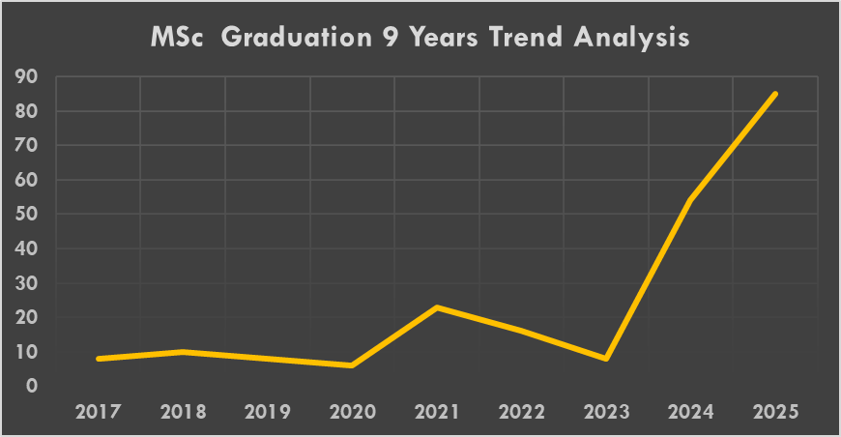

### 1.1.2 Summary of 2023 Intake by Program and Gender

The table below provides a summary of 2023 Intake by program and gender. In line with the student population in each program, Data Science and Analytics accounting for approximately 73% had the highest number of Intake, Statistical Science had approximately 12%, Mathematical Finance & Risk Analytics had approximately 8% while Biomathematics had approximately 7%

| **Program** | **Male Students** | **Female Students** | **Total no. of students** | **% Population** |
| --- | --- | --- | --- | --- |
| Master of Science in Mathematical Finance & Risk Analytics | 3 | 5 | 8 | 8% |
| Master of Science in Statistical Science | 4 | 8 | 12 | 12% |
| Master of Science in Biomathematics | 3 | 4 | 7 | 7% |
| Master of Science in Data Science and Analytics | 39 | 36 | 75 | 73% |
| **Overall** | **49** | **53** | **102** | **100%** |
| **% Total** | **48%** | **52%** | **100%** |  |

As per the above statistics per Master’s program, we noted that 48% of the 2023 Intake are Male whilst the Female make up for 52%. The Gender Statistics is further summarized in the following pie chart.

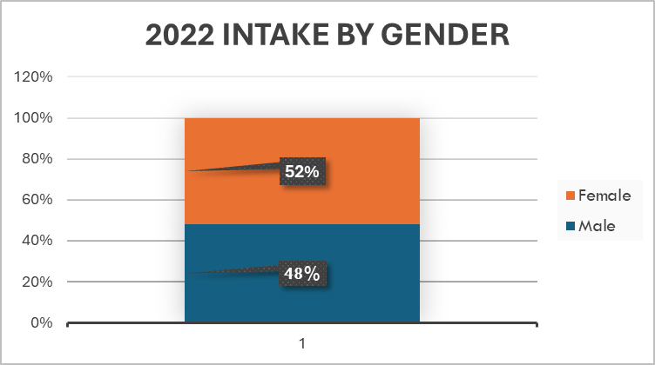

### **1.1.3 Masters of Science Graduation Rates**

### 2023 Cohort graduands Summary

The percentage completion rate of the 2023 cohort is shown in the following two tables. The overall graduation rate/completion rate for all the students admitted in 2023 is **33% (**See table below**).**

| **Program** | **2022 Intake** | **No. of Students Graduating** | **Completion Rate** |
| --- | --- | --- | --- |
| Master of Science in Mathematical Finance | 8 | 2 | 25% |
| Master of Science in Statistical Science | 12 | 7 | 58% |
| Master of Science in Biomathematics | 7 | 6 | 86% |
| Master of Science in Data Science and Analytics | 75 | 26 | 35% |
| **Overall** | **102** | **41** | **40%** |

The following graph shows the graduation rates since 2017 to 2025. Graduation rate is defined as the number of graduating students as a ratio of the number of students admitted in each cohort.

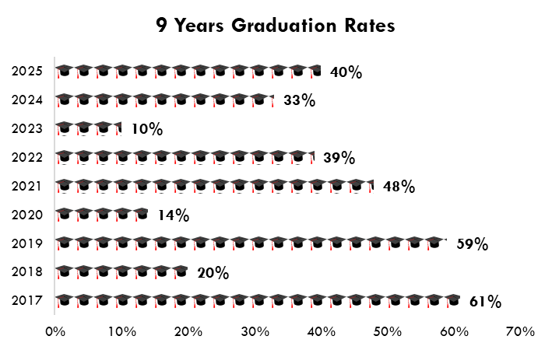

The Graduation Success Rate, that is, the ratio of the graduating students to the number of candidates who progress to Module IV/V shows steady performance over the years. The analysis is provided in the table below a

| **Program** | **2023 Intake** | **Module V 2024** | **Students Graduating** | **Success Rate** |
| --- | --- | --- | --- | --- |
| Master of Science in Mathematical Finance & Risk Analytics | 8 | 8 | 2 | 25% |
| Master of Science in Statistical Science | 12 | 11 | 7 | 64% |
| Master of Science in Biomathematics | 7 | 7 | 6 | 86% |
| Master of Science in Data Science and Analytics | 75 | 54 | 26 | 48% |
| **Overall** | **102** | **80** | **41** | **51%** |

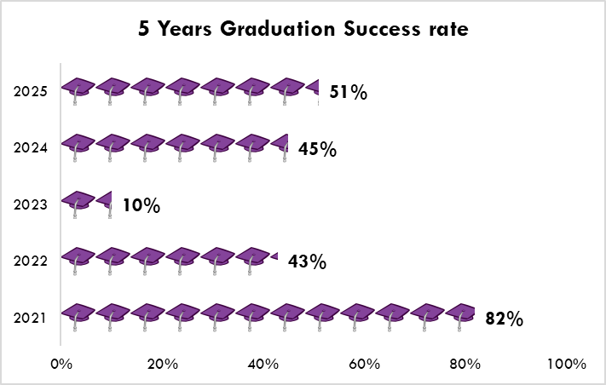

# **2.0 CLASS OF 2025 STATISTICS**

## **2.1 Overall Number of MSc. 2025 Graduands**

The number of graduands is as shown in the table below:

| **Program** | **2023 Intake** | **Backlog**  **(previous Cohorts)** | **Total** | **Percentage** |
| --- | --- | --- | --- | --- |
| Master of Science in Mathematical Finance & Risk Analytics | 2 | 10 | 12 | 14% |
| Master of Science in Statistical Science | 7 | 8 | 15 | 18% |
| Master of Science in Biomathematics | 6 | - | 6 | 7% |
| Master of Science in Data Science and Analytics | 26 | 26 | 52 | 62% |
| **Total** | **41** | **44** | **85** | **100 %** |

2.1.1 Summary of MSc Graduands by Program and Gender

The table below provides a summary of the graduands by program and gender. In line with the student population in each program: Data Science and Analytics accounting for approximately 62%, have the highest number of graduands, Statistical Science approximately 18% Mathematical Finance and Risk Analytics approximately 14%, and Biomathematics approximately 7%

| **Program** | **Male Graduands** | **Female Graduands** | **Total Graduands** | **% Graduands** |
| --- | --- | --- | --- | --- |
| Master of Science in Mathematical Finance & Risk Analytics | 5 | 10 | 15 | 18% |
| Master of Science in Statistical Science | 4 | 8 | 12 | 14% |
| Master of Science in Biomathematics | 2 | 4 | 6 | 7% |
| Master of Science in Data Science and Analytics | 24 | 28 | 52 | 62% |
| **Overall** | **35** | **50** | **85** | **100 %** |
| **% Total** | **41%** | **59%** | **100%** |  |

Approximately 41% of those graduating from the MSc Program in June 2025 are Male whilst the Female make up for 59%.

# **3.0 CLASS OF 2025 MASTERS GRADUATION LIST**

## **3.1 MASTER OF SCIENCE IN DATA SCIENCE & ANALYTICS**

I have the honour to present the following 52 candidates who during the 2024 – 2025 Academic Year satisfied the Board of Examiners of Strathmore Institute of Mathematical Sciences for the award of Master of Science in Data Science and Analytics of Strathmore University

| **S/No.** | **Student No** | **Student Names** | | **Gender** | | **Intake** | **Average Mark** | | **Average Grade** | **GPA** |
| --- | --- | --- | --- | --- | --- | --- | --- | --- | --- | --- |
| 1 | 147513 | AGONG, Norman Angel | Male | | May-22 | | | 64.21 | B | 3.09 |
| 2 | 145613 | ASWANI, Allan Ademba | Male | | May-21 | | | 71.36 | A | 3.46 |
| 3 | 169522 | BAARIU, Yvonne Makena | Female | | May-23 | | | 64.22 | B | 3.1 |
| 4 | 100054 | BABU, Eddah Waruguru | Female | | May-23 | | | 59.04 | C | 2.84 |
| 5 | 145110 | CHANN, Isaac Otieno | Male | | May-21 | | | 65.06 | B | 3.16 |
| 6 | 169194 | CHEPKIRUI, Sharon Tonui | Female | | May-23 | | | 75.38 | A | 3.7 |
| 7 | 169375 | CLAUDINE, Linda Wa Nciko | Female | | May-23 | | | 64.91 | B | 3.19 |
| 8 | 148454 | EYINDA, Christine Lorraine | Female | | May-23 | | | 74.34 | A | 3.75 |
| 9 | 149796 | GAMBO, Dawe David | Male | | May-22 | | | 68.38 | B | 3.34 |
| 10 | 169122 | GATHIMBA, Regina Wanjiru | Male | | May-23 | | | 61.46 | B | 2.95 |
| 11 | 169405 | IMENDE, Michael Edward | Male | | May-23 | | | 62.02 | B | 3.01 |
| 12 | 150961 | JEPKEMBOI, Jane | Female | | May-22 | | | 66.57 | B | 3.3 |
| 13 | 169701 | KAMANU, David Nene | Male | | May-23 | | | 74.75 | A | 3.73 |
| 14 | 94328 | KAMAU, Joyce Mukuhi | Female | | May-21 | | | 66.83 | B | 3.26 |
| 15 | 138536 | KARIUKI, Martin Mwangi | Male | | May-21 | | | 66.04 | B | 3.21 |
| 16 | 169111 | KATHURE, Bessy Mukaria | Female | | May-23 | | | 69.83 | B | 3.45 |
| 17 | 169123 | KEMBOI, Stella | Female | | May-23 | | | 67.65 | B | 3.29 |
| 18 | 168209 | KILONZO, Kelvin Ndambu | Male | | May-23 | | | 70.9 | A | 3.49 |
| 19 | 70707 | KILYUNGI, Bonface Munyoki | Male | | May-21 | | | 69.69 | B | 3.39 |
| 20 | 92833 | KIMANI, Wangari Ruth | Female | | May-22 | | | 65.32 | B | 3.17 |
| 21 | 149794 | KINYUA, Caroline Nyaguthii | Female | | May-22 | | | 69.66 | B | 3.46 |
| 22 | 169112 | KIPRONO, Jepkoech Gladys | Female | | May-23 | | | 69.16 | B | 3.44 |
| 23 | 148988 | KIRIMI, Dennis Mwenda | Male | | May-22 | | | 63.38 | B | 3.07 |
| 24 | 54667 | KIRUKI, Ruth Wambui | Female | | May-22 | | | 61.81 | B | 2.97 |
| 25 | 169240 | LUBANGA, Derrick Nyangule | Male | | May-23 | | | 64.26 | B | 3.15 |
| 26 | 78624 | MACHARIA, Crystal Njeri | Female | | May-22 | | | 73.84 | A | 3.69 |
| 27 | 77465 | MAINA, Anthony Mwangi | Male | | May-23 | | | 70.4 | A | 3.52 |
| 28 | 95729 | MAINA, George Kamau | Male | | May-23 | | | 65.54 | B | 3.22 |
| 29 | 168951 | MAINGA, Cecilia Oketch | Female | | May-23 | | | 75.43 | A | 3.78 |
| 30 | 94946 | MATANO, Allan Mutethiah | Male | | May-22 | | | 61.62 | B | 2.94 |
| 31 | 169540 | MAVINDU, Ruth Mwende | Female | | May-23 | | | 66.42 | B | 3.32 |
| 32 | 149910 | MBUTHU, Valentine Masungwa | Female | | May-23 | | | 64.84 | B | 3.17 |
| 33 | 152377 | MUCHOKI, Eric Brian Muturo | Male | | May-23 | | | 66.91 | B | 3.24 |
| 34 | 169118 | MUKHANYA, Moses Wabwile | Male | | May-23 | | | 63.14 | B | 3.07 |
| 35 | 145063 | MULE, Daniel Mbatha | Male | | May-21 | | | 64.72 | B | 3.13 |
| 36 | 151147 | MWADIME, W Nicholas | Male | | May-22 | | | 63.34 | B | 3.12 |
| 37 | 94573 | MWANGI, Morrine Nduta | Female | | May-22 | | | 62.94 | B | 3.03 |
| 38 | 169526 | NGARUIYA, Esther Nduta | Female | | May-23 | | | 71.27 | A | 3.58 |
| 39 | 168403 | NYABUTI, Sharon Kemunto | Female | | May-23 | | | 63.52 | B | 3.12 |
| 40 | 145615 | ODERA, Yvonne Juliana Dima | Female | | May-21 | | | 63.4 | B | 3.08 |
| 41 | 166895 | OGADA, Joseph Ridge | Male | | May-23 | | | 67.74 | B | 3.32 |
| 42 | 100060 | OGAMBA, Maria Bosibori | Female | | May-22 | | | 64.39 | B | 3.19 |
| 43 | 82706 | OKERO, Michael Omondi | Male | | May-22 | | | 62.19 | B | 2.97 |
| 44 | 169093 | OLADIRAN, Monilade Omolola | Female | | May-23 | | | 68.03 | B | 3.37 |
| 45 | 149481 | ONYANGO, Calvince Ogutu | Male | | May-22 | | | 64.85 | B | 3.14 |
| 46 | 150904 | OPIYO, Carol Akinyi | Female | | May-22 | | | 67.44 | B | 3.32 |
| 47 | 54952 | ORWARU, Rose Kwamboka | Female | | May-21 | | | 61.66 | B | 2.88 |
| 48 | 150683 | OSORO, Faith Mirriam | Female | | May-22 | | | 66.24 | B | 3.26 |
| 49 | 51234 | OUMA, Munyendo Evans | Male | | May-21 | | | 72.5 | A | 3.5 |
| 50 | 169589 | WAMALWA, Lindah Kelida | Female | | May-23 | | | 72.49 | A | 3.53 |
| 51 | 94306 | WANYOIKE, Eunice Waruguru | Female | | May-21 | | | 59.55 | C | 2.85 |
| 52 | 167860 | WASWA, Paul Wekesa | Male | | May-23 | | | 63.91 | B | 3.15 |

## **3.2 MASTER OF SCIENCE IN STATISTICAL SCIENCE**

I have the honour to present the following 15 candidates who during the 2024 – 2025 Academic Year satisfied the Board of Examiners of Strathmore Institute of Mathematical Sciences for the award of Master of Science in Statistical Science of Strathmore University

## **3.3 MASTER OF SCIENCE IN MATHEMATICAL FINANCE & RISK ANALYTICS**

I have the honour to present the following 12 candidates who during the 2024 – 2025 Academic Year satisfied the Board of Examiners of Strathmore Institute of Mathematical Sciences for the award of Master of Science in Mathematical Finance and Risk Analytics of Strathmore University

## **3.3 MASTER OF SCIENCE IN BIOMATHEMATICS**

I have the honour to present the following 6 candidates who during the 2024 – 2025 Academic Year satisfied the Board of Examiners of Strathmore Institute of Mathematical Sciences for the award of Master of Science in Biomathematics of Strathmore University

# **4.0 2023 COHORT LIST OF BACKLOG STUDENTS**

### 4.1 Summary of 2023 Cohort Pending Students

| **Program** | **2023 Intake** | **No. Graduating** | **Dropped out/ Transferred** | **Pending Students** | **% Pending** |
| --- | --- | --- | --- | --- | --- |
| Master of Science in Mathematical Finance | 8 | 2 | - | 6 | 70% |
| Master of Science in Statistical Science | 12 | 7 | - | 5 | 53% |
| Master of Science in Biomathematics | 7 | 6 | - | 1 | - |
| Master of Science in Data Science and Analytics | 75 | 26 | 2 | 47 | 63% |
| **Overall** | **102** | **41** | **2** | **59** | **58%** |

### **4.1.1 2023 Cohort List of Pending Students**

### 4.1.2 MSc. Mathematical Finance & Risk Analytics

| **4.1.5 MSc Data Science & Analytics** | | | |
| --- | --- | --- | --- |
| **S/No.** | **Student Number** | **Student Details** | **No. of Pending Units** |
| 1 | 168213 | Mureithi, Esther Wanjiku | 1 Unit |
| 2 | 169406 | Amule, Edward | 1 Unit |
| 3 | 80925 | Ng'ang'a, Simon Kihara | 2 Units |
| 4 | 69298 | Wawire, Mercyline | 2 Units |
| 5 | 96002 | Gitonga, John Mwangi | 2 Units |
| 6 | 150119 | Theuri, John Gitonga | 2 Units |
| 7 | 169116 | Ngetich, Abraham | 2 Units |
| 8 | 169124 | Kigotho, Samuel Irungu | 2 Units |
| 9 | 169126 | Wabwoba, S. Abigail | 2 Units |
| 10 | 169274 | Orege, Ian Kesohore | 2 Units |
| 11 | 61596 | Kihang'a, Solomon Wabacha | 3 Units |
| 12 | 95244 | Kirwa, Cherono Brenda | 3 Units |
| 13 | 167209 | Nyaberi, Graham Nyasoko | 3 Units |
| 14 | 168952 | Mbugua, Alex Gikaru | 3 Units |
| 15 | 169113 | Sonye, Henry Ayah | 3 Units |
| 16 | 100258 | Gachoka, Eva Wanjiru | 4 Units |
| 17 | 78377 | Kitui, Paul John | 3 Units |
| 18 | 168363 | Ibrahim, Naima Mohamed | 4 Units |
| 19 | 169376 | Obunga, Jean Keith | 4 Units |
| 20 | 121777 | Simala, Odhiambo Leonard | 5 Units |
| 21 | 152226 | Obaga, Emmanuel Bongwe | 5 Units |
| 22 | 168211 | Ochieng, Atieno Mercy | 6 Units |
| 23 | 169702 | Otieno, Horace Ouma | 7 Units |
| 24 | 63827 | Kiplagat, Beatrice Jelimo | 8 Units |
| 25 | 168950 | Kiprop, Jepkosgei Judith | 8 Units |
| 26 | 169127 | Mohammed, Abdulaziz Rajab | 8 Units |
| 27 | 169371 | Aswani, Fridah Obuchela | 9 Units |
| 28 | 101327 | Sindayikengera, Lily Jorelle | 9 Units |
| 29 | 76829 | Ng'ang'a, Sheila Wambui | 10 Units |
| 30 | 136686 | Waithaka, Brooklyne Njeri | 11 Units |
| 31 | 93938 | Kiplagat, Kelvin Kimutai | 12 Units |
| 32 | 168210 | Mwaniki, Erastus Musili | 13 Units |
| 33 | 78232 | Kariuki, Francis Kabutu | 14 Units |
| 34 | 169125 | Washiali, Mashere Susan | 14 Units |
| 35 | 168332 | Kandeya, Rutendo Julia | 15 Units |
| 36 | 95381 | Ototo, Alphonsinah Mogoi | 17 Units |
| 37 | 169114 | Samoe, Stacey | 17 Units ACADEMIC LEAVE |
| 38 | 49618 | Muriuki, Kevin Maina | 18 Units |
| 39 | 166573 | Peter, May Mumbua | 18 Units ACADEMIC LEAVE |
| 40 | 169411 | Ooko, Hesbon Odhiambo | 20 Units |
| 41 | 75786 | Mbotela, Immanuel Malombe | 21 Units |
| 42 | 152906 | Sugut, Grace Jerono | 21 Units |
| 43 | 167205 | Kipkoech, Mark | 21 Units |
| 44 | 169117 | Odanga, Hilda | 21 Units |
| 45 | 169374 | Mwanza, Maurice Mutua | 21 Units |
| 46 | 169529 | Malu, Muamba Mylene | 21 Units |

## **4.2 Other Cohorts (Backlog)**

4.2.1 MSc. Data Science and Analytics

| **S/No.** | **Student Number** | **Student Details** | **Class of** | **No. of Pending Units** |
| --- | --- | --- | --- | --- |
| 1 | 151148 | Nderito, Kigen Gatere | 2024 | 1 Unit (Dissertation) |
| 2 | 149076 | Njogu, Charles Kabui | 2024 | 1 unit (DSA 8302) |
| 3 | 83303 | Ramadhan, Khidir Ismail | 2024 | 2 Units |
| 4 | 69139 | Awuor, Joyce Naomi | 2024 | 4 Units |
| 5 | 150684 | Waithera, Richard Kabiru | 2024 | 5 Units |
| 6 | 149978 | Gichuki, Michael Mwangi | 2024 | 6 Units |
| 7 | 050953 | Bodo, Joyce Anyango | 2024 | 7 Units |
| 8 | 78375 | Otieno, Billy Opiyo | 2024 | 11 Units |
| 9 | 151384 | Joseph, Anette Kerubo | 2024 | 11 Units |
| 10 | 148987 | Jaffery, Mwangi Ndisho | 2024 | 13 Units |
| 11 | 81757 | Yogo, Lousa Sheenaz | 2024 | 15 Units |
| 12 | 102156 | Papa, Blaise | 2024 | Academic Leave |
| 13 | 110445 | Njimu, Stacy Waithera | 2024 | Deferred |
| 14 | 46724 | Kariuki, Michael Gichure | 2024 | Deferred |
| 15 | 151617 | Migolo, Naboth Benjamin | 2024 | Deferred |

| 16 | 145684 | | Ndiritu, Timothy Wahome | 2023 | 1 Unit (Dissertation) |
| --- | --- | --- | --- | --- | --- |
| 17 | 144910 | | Onyango, James Oduor | 2023 | 1 Unit (Dissertation) |
| 18 | 145052 | | Mboya, Daisy Akinyi | 2023 | 1 Unit (Dissertation) |
| 19 | 145056 | | Nguti, Lydia Mukii | 2023 | 1 Unit (Dissertation) |
| 20 | 145076 | | Muninzwa, Donstefano Afubwa | 2023 | 1 Unit (Dissertation) |
| 21 | 71167 | | Rugendo, Esther Muthoni | 2023 | 1 Unit (Dissertation) |
| 22 | 145111 | | Makori, Joseph Orina | 2023 | 1 Unit |
| 23 | 144894 | | Mugambi, Mike | 2023 | 1 Unit |
| 24 | 78052 | | Simiyu, Barbara Lusike | 2023 | 1Unit |
| 25 | 106218 | | Gichuhi, Getrude Gathoni | 2023 | 2 Units |
| 26 | 144896 | | Juma, Joseph Matundura | 2023 | 2 Units |
| 27 | 145049 | | Ambutu, Joan Karimi | 2023 | 2 Units |
| 28 | 145054 | | Kyalo, Henry Muoki | 2023 | 2 Units |
| 29 | 145628 | | Mutugi, Antoinette Ndega | 2023 | 3 Units |
| 30 | 95227 | | Sime, Victor Omondi | 2023 | 4 Units |
| 31 | 84705 | | Musombi, Christian Bruce | 2023 | 6 Units |
| 32 | 78952 | | Wanjiru, Sally | 2023 | 9 Units |
| 33 | 145616 | | Mise, Lucy Muhonja | 2023 | 8 Units |
| 34 | 145078 | | Sammy, Beritah Catherine | 2023 | 9 Units |
| 35 | 134000 | | Oyatsi, Adera Alexander | 2023 | 16 Units |
| 36 | 144893 | | Wanambuko, Emmanuel Mukhebo | 2023 | 16 Units |
| 37 | 91265 | | Gitahi, Stephen Kinyua | 2023 | 16 Units |
| 38 | 71071 | | Oguda, Alex Onyino | 2023 | Deferred |
| 39 | 145108 | | Onyango, Victor Omondi | 2023 | Deferred |

**Approval of June 2025 MSc Graduation Report**

This June 2025Graduation List is approved by;

The Examination Board:

Strathmore Institute of Mathematical Sciences

Dean **…………………………………………** Date **………………………**

Academic Council

DVC, Academics and Student Affairs.

Sign**……………..……………………………………….** Date **………………………**

Vice Chancellor

Sign**……………...……………………………………….** Date **………………………**